

PT. SINKO PRIMA ALLOY
Alamat : Jl. Tambak Osowilangun Permai No. 61,
pergudangan osowilangun permai Blok E7-E8,
Surabaya-Indonesia (60191)
Telepon : 031-7482816
Fax. : 031-7482815
Aftersale (WA) : 0821-4281-7085
Email : aftersales@elitech.co.id
sinkoprima@gmail.com
Website : www.elitech.id

SPA-BM/PROD-241. 18 September 2025. Rev00

Brief Introduction
Thank you for purchasing our TOP-308 Upgrade Dental Unit. With ABS draw plastic shell, it is free of distortion, depigmentation, toxin and harm with full-computerized autocontrol; it has such advantages as solid structure, handsome shape, easy operation and high reliability as an ideal upgraded product for the modern dental clinics.
The dental chair adopts low-pressure mute DC motor driving and full-computerized control with two control points at main switch and foot switch. The design of the control switches is lines with the human mind and behavior habits, which greatly increases the instrument’s safety index, facilitate the dentist to work accurately and quickly. Its cushion adopts the integrated seamless foaming technology. The dental unit adopts the new-type long-lived lamp arm, novel induction dental cold light lamp, integrated ceramic gargle Cuspidor and airlock balance arm, all add luster to the unit. Its high/low-speed handpiece adopts the independent water supply system, which can prolong the service life of the handpiece. Compared with the two-holed handpiece, the four-holed handpiece has the extra exhaust and scrap-blowing function. The cooling water has the extra suckback-proof design that can prevent cross infection between patients. It adopts three way syringe 1 pieces for cold and the dual (strong/weak) saliva ejectors.
TS-TOP300 Folding Full-computerized Comprehensive Integrated Dental Unit is made up of the dental unit and the full-computerized dental chair. This instrument will create good economic and social benefits for you.

Technical Parameters
Power supply : AC 210V – 240V
Frequency : 50Hz
Input power : 800VA
Mains power supply : FR1-20 φ5 × 20 5A
Input of air pressure : 0.5 ~ 0.8MPa Flux≥50L / min
Input of water pressure : 0.2 ~ 0.4MPa Flux≥10L / min
Environmental temperature: 5 ~ 40 ° C Relative humidity≤80%
Water temperature : 45 ± 5 ° C
Max. Round. Of high speed handsets: 90.000r / min
Max. Output torque≥6g.cm (Air pressure: 0.22Mpa)
Max. Round. Of low speed handset: 20.000r / min
Max. Output torque≥10g.cm (Air pressure: 0.3MPa)
This Dental Unit loads continuous time≤15min
Dental This unit contains a continuance≤60% (working hours of this seat / interval)
Note: In this machine, the blue tube for the waterway, the transparant tube is for the working air ducts, and the gray and white tubes for the air ducts control.

Function Symbols

 | Backrest forward button |  | Backrest backward button
 | Chair up button |  | Chair down button
 | Next page |  | Previous page
 | Lock screen button |  | Cuspidor wash button
 | Water supply button |  | Heating button
 | Operating lamp button |  | Mouth wash position
 | X-ray film view button |  | User(doctor) button A/B/C
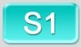 | Memory position I |  | Memory position II
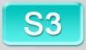 | Memory position III |  | Reset button
 | First aid position |  | Set button
 | Pipe disinfection button |  | Clean position button
 | Time and date

Installation
- Preparation
Decide where to install the machine according to the overall arrangement, lighting and availability of the clinic. Put the machine in a clean, dry, draughty and cool place as good working conditions. Make sure that the dental chair chassis contacts the even and solid floor. Under the floor box, there must be inlets/outlets for water, gas and electricity for the machine within the range of 140×120mm. The water inlet pipe and air intake pipe should be the 8×5 PU pipes. The drainpipe should be the hosepipe atΦ40mm(3/2″). The port of each pipe is about 40mm away from the floor. The input wire should be the 3-core 1mm jacketed cord, about 400mm away from the floor. And connect the protective ground wire well. For the detailed dimensions.
- Unpack the Carton for Inspection
Unpack the carton to verify that the whole machine is intact. And check whether the accessories and spare parts are complete and intact according to the packing list. For any questions, please inquire the dealer or our company at once.
- Installation of the Mainframe
Firstly, put the dental chair in the right place. The design of this machine considers the stability of the whole machine, so the foot-fixing screws are unnecessary. But the dental chair chassis must contact the even and solid floor for fear of accidents.
In case of rotation or declining of the whole machine due to the uneven floor, one can fasten the six M12 inner hexad flat end fixing screws into the six M10 screwed holes on the dental chair chassis, and make it fully contact the floor. During the adjustment, please keep the whole machine even and guarantee as many contact points as possible, so as to ensure the stability of the whole machine.
- Installation of the Induction Dental Lamp
Put the wire from the lamp arm through the lampstand, and then connect the two well. After that, connect the wire connector on the lamp arm to that in the dental cabinet, and put them into the column. Then put the lampstand onto the column, and put the lamp arm in the right place. (Note: don’t damage the wire.)
Connect the lamp base wire inserter through the decorative jacket to the lamp arm wire inserter, insert the lamp base handle into the lamp arm hole, and fasten it with screws, and then cover the screw and seam with the decorative jacket.

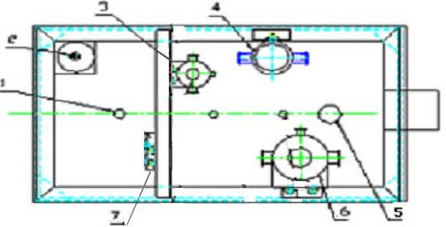

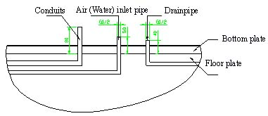

Fig. 1 Floor Box

1. Conduits 6. Air filter reducing valve
2. Transformer 7. Wire unit
3. Small reducing valve
4. Water filter
5. Barometer

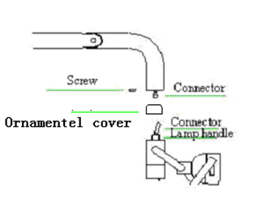
Fig.2 Induction Dental Lamp

Fuction Description
- Restore factory settings:
After the system is installed, press and hold the setting button for about 10 seconds. After hearing the buzzer, release your hand and the chair will move automatically: the first stage: the seat is lowered to the lowest point and the backrest is raised to the highest; the second stage, the seat When the chair rises to the highest position, the backrest drops to the lowest position; the third stage: the chair moves to the reset state, the buzzer does not sound, and after 1 second, the system emits beeps:
After the factory reset is completed, the cup water time is restored to the default value of 3 seconds, the flushing time is 30 seconds, and the program bit S1/S2/S3 returns to the default position; during the movement of the chair, press any key, the buzzer will beep for a long time, Can exit settings;

- Key Description
Chair up  | Press and hold the seat up button, the seat will rise, release it to stop, the limit will automatically stop; the limit switch will automatically stop when the limit switch is closed
Chair down  | Press and hold the seat down button, the seat will drop, release it to stop, the limit will automatically stop; the limit switch will automatically stop when the limit switch is closed
Backrest forward  | Press and hold the backrest forward button, the backrest rises, release to stop, the limit position automatically stops; the limit switch closes automatically to stop；
Backrest backward  | Press and hold the backrest backward button, the backrest will fall, release it to stop, the limit position will automatically stop; the limit switch will automatically stop when the limit switch is closed
Reset  | Short press the RESET button, the icon turns blue , the seat moves to the lowest position, and the backrest moves to the highest position; during the movement of the chair, press any key to stop the movement immediately.
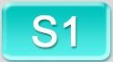      S1/S2/S3 Position | Short press the S1 button, the icon turns blue , the chair moves to the set position, and the chair stops moving immediately by pressing any key during the movement
Mouth wash SP  | Short press the SP button, the icon turns blue, turn off the dental light, turn on the cuspidor wash button, the backrest rises to the highest position, short press the SP button again, the backrest moves back to the working position, when it is in place, turn off the flushing bowl and turn on the dental light; in the rinsing position (The chair back moves to the highest position), operate the button function related to the motor, cancel the mouthwash position program, operate the button function not related to the motor, and cannot affect the normal operation of the mouthwash position program, press any key during the movement of the chair to stop immediately sports
Cleaning position  | Short press the cleaning button  to open the flushing bowl, the seat moves to the highest position, and the backrest moves to the highest position. Press any key to abort the cleaning position procedure and close the flushing bowl. If no key is pressed to interrupt the cleaning position procedure, 1 hour later The flushing bowl is automatically closed; during the movement of the chair, press any key to stop the movement immediately, exit the cleaning position program, and enter the standby state
First aid | Short press the emergency button , the icon turns blue , the seat back moves to the lowest position, the seat moves to the highest position, and press any key during the movement of the chair to immediately stop the movement and enter the standby state
Heating  | Short press the heating button, turn on the heating, the icon turns blue  (the heating indicator light is beating@regular main control), the three bars above the cup icon beating, the temperature reaches the set value, the temperature control switch is disconnected, the water heater pauses heating, and the three bars above the cup icon Stop beating (the heating indicator light is always on conventional main control), the temperature is lower than the set value, the water heater automatically heats up, the heating indicator light jumps, and the cycle is repeated; short press the heating button again to turn off the heating of the water heater; during the heating process, the motor Exercise, the water heater suspends heating, the heating indicator light is off, and the heating automatically resumes after the motor stops moving, and the heating indicator light is on.
Operating lamp  | Short press the operating lamp button to turn on the operating lamp, the icon turns blue , short press the operating lamp button again to turn off the operating lamp
X-ray film view | Short press the X-ray film view button to turn on the X-ray film view, the icon turns blue , short press the X-ray film view button again to turn off the X-ray film view
Water supply  | Short press the water supply button to open the water supply solenoid valve, the icon turns blue , short press the water supply button again to close the water supply solenoid valve; the default water filling time of the system is 3 seconds, if there is no short press to close, then add water according to the set time , when the time is up, it will automatically stop adding water. Please refer to the SET button for setting the water-adding time
Cuspidor wash  | Short press the cuspidor wash button to turn on the cuspidor wash, the icon turns blue , short press the cuspidor wash button again to close the cuspidor wash, the default cuspidor wash time of the system is 30 seconds, if there is no short press to close, then press the set time to flush the cuspidor, the time When it is time to automatically stop cuspidor wash, please refer to the description of the SET button to set the cuspidor wash time.

Debugging

- Turbine handpiece (optional)
Switch on the waterway, airway and circuit. The hydraulic pressure should be 0.2~0.4Mpa. Too low hydraulic pressure would influence the normal water output, and too high hydraulic pressure would influence the airtighness of the whole machine. The filter reducing valve’s reduced air pressure should be 0.55~0.6Mpa. For any error, one must adjust the corresponding filter reducing valve to control the air pressure within a certain range. To do that, one should uncover the floor box, and pull the revolving handle on top of the filter reducing valve up about 10mm, and then turn the revolving handle clockwise to lift it or counter-clockwise to descend it.

The water supply of the handpiece comes from the water storage tank directly. Its outlet water pressure is decided by the air pressure into the water storage tank, which is controlled by the dedicated reducing valve inside the floor box. Uncover the floor box to check the voltmeter on the reducing valve, and make sure that the reading is 0.2mPa. For any error, please adjust the reducing valve to the above reading. The adjustment method is the same as that for adjusting the filter reducing valve.

Take up the turbine handpiece from the hanger, and step on the switch on the left of the air control. Then the turbine handpiece will go round to spray out cooling water, when the high-speed turbine handpiece will begin to work. Note: at this moment, the pressure reading in the voltmeter on the instrument tray indicates the working pressure of the turbine handpiece (*1), which cannot exceed the max. rated pressure of the turbine handpiece for fear of damaging it. To adjust the working pressure of the turbine handpiece, one can use the master control valve behind the instrument tray, clockwise for lower pressure, and vice versa. Please adjust it carefully and slowly.
This machine adopts the four-holed handpiece with scrap blowing function. For independent scrap blowing, one can step on the middle pedal. The flux of the cooling water is also adjustable: just turn the water volume below the instrument tray. The turbine handpiece is a precision apparatus, so please read the relevant user’s manual carefully before using it.
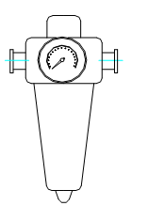
Fig.3 Filter Reducing Valve

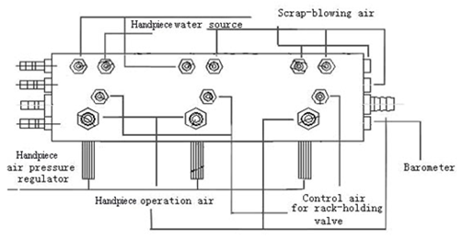
Fig.4 Main Control Valve

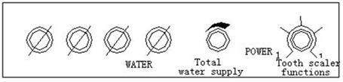
Fig.5 Control Valve for Tooth Scaling/Water Supply

- Three-way syringe
This unit has warm-water three-way syringe on the instrument tray which has warm water supplied by internal automatic constant-temperature water-heater. If warm water is required, just press the water heater switch on the control panel, and the heater booms slightly for a short time (the same sound as pressing other keys, except for C-type motor), with indicator light flashing on and off, which means the internal water heater starts heating and water temperature comes up. Once water temperature reaches the specified point, the heater will stop automatically, with indicator light on, and it enters waiting state. If water cools down, the heater will start again with indicator light flashing on and off. It works repeatedly as shown above to ensure the constant temperature of water supplied.

- Saliva ejector
This unit has saliva ejector which will start operation the moment when it is taken off the rack. Weak ejection is realized by water suction, therefore it must be connected with water supply which can ensure its lowest operation water pressure.
- Tooth scaler
Electric ultrasonic tooth scaler, which is optional unit chosen by the customer, can be equipped on TOP-308 Upgrade unit.
If electric ultrasonic tooth scaler is furnished, just take the handpiece of the tooth scaler from the rack and step on the pneumatic foot control, then the tooth scaler will start vibration. Mind you, the tooth scaler only works when there is water, otherwise it may cause damages to it. Water output can be adjusted the same way as that for turbine handpiece (Fig.5). Its output power can also be adjusted with adjusting button on the bottom of the instrument tray (Fig.6). The head of the tooth scaler must be tightened, otherwise it may affect the output power.
As electric tooth scalers are delicacy items, please read carefully about its operation manual before using.
- Gargling water
The gargling water supply system of this unit has constant temperature and water quantity setting functions. As its warm water is supplied by internal constant-temperature water-heater, please press the heater switch if warm water is required (Fig.7), with water heater working in the same way as for three-way syringe. Water output is controlled by built-in computer control panel which can be set by the user at will. Please press “SET” on control panel of the instrument tray firstly when setting, and indicator light goes on, then place an empty cup on the outlet of gargling water and press “Gargling Water” on the control panel continuously, the water will come out. Release the key until water in the cup reaches the level what you want, and the water flow stops. Finally press “SET” on control panel again and indicator light goes out. All above procedures are memorized by the computer and setting completed. In actual using, just press “Gargling Water” on the control panel once, the computer will fill water once automatically according to the set value, which is set by the user at his/her will.
During gargling water supplying, just press “Gargling Water” again if you want to stop the water. The way of inputting the same signal to terminate the corresponding actions during operation is also valid for other functions.

- Cuspidor cleaning water
- Press SET continuously, and indicator light goes on.
- Press cuspidor cleaning key, with detailed time limit described below:
a. Press once, the water will flush for 30 minutes and indicator light flashes once.
b. Press twice, the water will flush for 60 minutes and indicator light flashes twice.
c. Press three times, the water will flush without automatic stopping and indicator light flashes three times.
d. Press four times, the water will flush for delivery test. The indicator light flashes four times and water flushing for 12 seconds.
Please press “SET” again after setting finished, then the indicator light will become dark and setting completed. All these are memorized by the computer for future use, just press the cuspidor cleaning key gently and water will come out automatically and stop at the set time. (The water will stop once pressing cuspidor cleaning key during water flushing.)
- Water bottle
Water for handpieces is directly from the water bottle, therefore the bottle shall be supplied with medical distilled water on time, with water filling described as below: Turn off the air switch beside the water bottle firstly. After all the compressed air in the bottle discharged, hold the water bottle securely and turn clockwise to take it off. Then fill water in it and turn it on counter-clockwise, until it fixed on the bottle cup tightly (Air tightness must be regarded). Finally turn on the air switch and water filling completed.
- Head holder
The head holder of this unit has two optional adjusting locations, one is for adults and the other is for children. Angle and height of the head holder in each location are adjustable (Fig.8). If you want to adjust the angle of the head holder, first hold the head holder, then turn handle 1 to the position you want and tighten it. As for the height of the head holder, just pull out or push down the head holder to the required position directly and make the head holder in its best way by small adjusting. Attentions: After adjusting the position of the head holder, it must be locked tightly to avoid accidents during operation.
- Ascending/Descending of the dental chair
The dental of this unit has two controls and moving of the dental chair can be controlled by control panel or the foot switch, either one will do.
As for the ascending of the dental chair, just press the control key above the dental chair symbol on the control panel with upward arrow on it; or step on the foot switch on the arrow upward, the dental chair will go up, meanwhile, corresponding indicator light on the control panel turns bright. Release the key and dental chair will stop rising and light will become dark. If pressing the control key continuously and the chair reaches its extreme position, it will stop moving automatically even if pressing the key on.
The same way is for the descending of the dental chair, just pressing control keys above the dental chair symbol with arrow downward. There is also lowest limit for descending.
Remark: As there are moving parts in the dental chair of this unit, while the unit is connected with these moving parts and moves with the dental chair, please ensure there is nothing touchable within the whole travel distance of the unit to avoid accidents.

7. Maintenance
1. Cleaning & Lubrication of the handpiece
Please refer to operation manual of the handpiece.
2. Water filter
Water filter is installed at water inlet of the floor box of the unit to block off the impurities in the water (Fig.10), so as to ensure normal operation of the unit. After long time service, the filter core may be choked up by dirt, therefore must be cleaned or replaced to ensure normal water flow.
Generally, cleaning or replacing the filter core once any of the following things occurs:
i. Already used for more than a year;
ii. Pressure loss of the filter core exceeds0.1Mpa;
iii. Filter core contaminated;
iv. Water output is not clear;
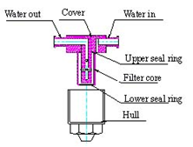

Fig.6 Water Filter
Procedures for cleaning/replacing of the filter core: Open the floor box cover and take out the water filter, remove the water filter hull by turning it in counter-clockwise direction, then take off the seal ring and filter core in turn. After cleaning or replacing them, assemble the water filter back in reversed sequence and pay attention to its air tightening.
3. Filter reducing valve
In order to ensure clean dry air of stable pressure input in this unit, air filtering reducing valve is installed at the inlet of the floor box to control the air pressure not to exceed its set value and also eliminating the impurities and moisture in the filtering air to some extent. The water content filtered will be condensed in the filter cup and shall be discharged after long time filtering to ensure satisfactory filtering effects.
Water discharging of the reducing valve must be performed if any of the following occurs:
i. Already used for more than a week;
ii. Water in the filter cup reaches three-fourth of the total volume;
iii. Water color changed in the filter cup ( not clear any more).
Procedures for water discharging of the reducing valve: Remove the floor box cover, turn the nut under the filter clockwise by hand, then the water will flow out. After all the water has been discharged, screw up the nut counter clockwise. In order to keep it clean around, you can place water-absorbing items, such as cotton cloth, toilet paper, sponge, etc., at the water outlet to absorb the discharged water.
4. X-film Viewer
X-film viewer is used for watching X-films, while it may be damaged after long time service and just replace it if that occurs.
Operation steps:
i. Cut off power.
ii. Remove the back cover and you can find the U-shape energy-saving light tube (12。5V,7W) in it, check whether the light tube is loose or damaged, repair or replace it, then assemble it back as before.
Attentions: The light using 220V high-voltage electricity, please be sure to cut off power supply before handling.
5. Holding rack valve
Insert the core of the rack holding valve into the rack holding box and fix it with fastening screw, with interval between the core valve and detector adjustable. Under normal conditions, place handpiece or saliva ejector into the holding rack and push in the detector. Make the valve core moving left and block air route with four 1.2 rubber O ring. In case that the air flow does not stop even after inserting the handpiece, or there is air leakage after saliva ejector or handpiece put back into the holding rack, just loosen the fastening screw and move the holding valve right, check whether the valve can be locked to cut the air flow. If it does not work, it is necessary to disassemble the rack holding valve to see whether O ring has been damaged.
Detailed steps:
i. Cut off air supply.
ii. Loosen the fastening screw and take out the rack holding valve. Pull out the valve core and you can find the O ring (Fig.11).
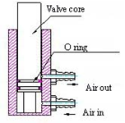
Fig.7 Rack Holding Valve

6. Troubleshooting

Error code | Error name | Troubleshooting methods
E01 | Main controller (program controller) communication  failure | Please check whether the main control communication line is  plugged in properly
E02 | Assistant control communication failure | Please check whether the assistant control communication line is plugged  in properly
E03 | Seat motor failure | Please check whether the seat motor communication line is  plugged in properly
E04 | Backrest motor failure | Please check whether the backrest motor communication  line is plugged in properly
E05 | Seat sensor failure | Please check whether the seat sensor communication line is  plugged in properly
E06 | B ackrest sensor failure | Please check whether the backrest sensor communication  line is plugged in properly
E07 | Flushing water solenoid valve failure | Please check whether the solenoid communication line is  plugged in properly
E08 | Water supply solenoid valve failure | Please check whether the solenoid communication line is  plugged in properly

Precautions:
- During the operation of the dental chair, it must be ensured there is nothing touchable within the travel scope of the chair.
- Remove the deposited water in the filter reducing valve in time.
- Clean or replace water filtering core in time.
- Filter cup of weak ejection must be cleaned once every month.
- During direct control of the dental chair ascending/descending, the control key must be pressed on continuously until to the position wanted.
- After the head holder has been adjusted to the required position, it must be locked before using.
- Power supply must be cut off when replacing electric components.
- Power supply must be cut off before maintaining and cleaning of the unit.
- Optional parts equipped on this unit, such as the tooth scaler and curing light, must be excellent CE products.
- Transportation & storage environment:
- Ambient temperature: -40 ~ +70°C;
- Relative humidity: 10%~100%, including condensation;
- Air pressure: 500~1060hPa.
- The unit must be protected from rain during transportation and handle it gently to avoid shock.
- The packed unit shall be stored indoors where the relative humidity not exceeding 80%, no corrosive gas and air flows well.

- Disposal of waste water and other things must meet the local environment protection regulations.
- Maintenance of the unit must be done by the professional technicians designated by our company. The unit may be damaged if the user disassemble and repair it on his/her own, and it will not enjoy our maintenance service any more if that occurs.

Circuit Schematic Drawing
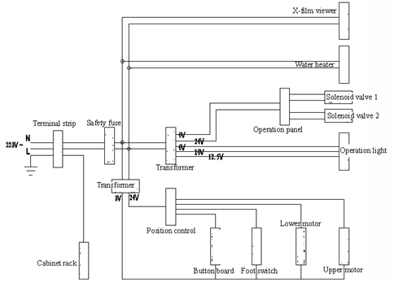

Water & Pneumatic Connection Drawing
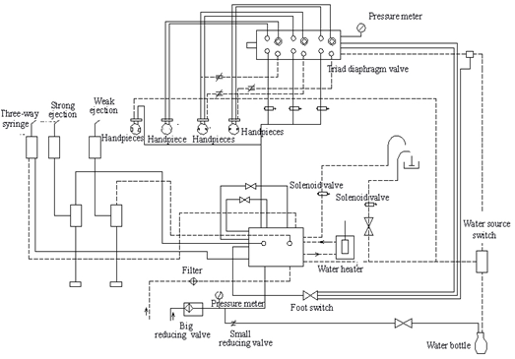

DENTAL UNIT
TOP-308
(UPGRADE)


Manual Book




